Thomas Slagle (72602272)

**Source Panel Project**

**A. Overview**

This assignment provides the results for a Python Program that estimates the coefficient of pressure over the surface of a cylinder with radius 1 in a freestream flow. The source panel method is a basic Computational Fluid Dynamics (CFD) method for breaking down an arbitrary shape into smaller components, or panels, and estimating the aerodynamic quantities on each panel. The results of this code were also compared to the analytical solution which provides an exact solution to the source panel approximation.

**B. Governing Equations**

Start with (1), which defines the infinitesimal potential function along the shape. (2) integrates the function and defines the potential function for the entire shape.

$dϕ=\frac{λds}{2π}ln(r)$ (1)

$ϕ\left(x,y\right)= \int_{a}^{b}{\frac{λds}{2π}ln⁡(r)}$ (2)

For the source panel method, the function (shape) is broken down into linearly varying panels. For the jth panel, where there are a finite n panels; the following equations hold:

$Δϕ_{j}=\frac{λ_{j}}{2π}\int_{j}{\ln\left(r_{ij}\right)ds_{j}}$ (3)

(3) gives the contribution to the potential function at point P (center) from panel j.

$V_{n_{i}}=\frac{∂}{∂n_{i}}\left[ϕ\left(x_{i},y_{i}\right)\right]=\frac{λ_{i}}{2}+\sum_{\begin{aligned}j=1 \\ \end{aligned}}^{n}{\frac{λ_{j}}{2π}\int_{j}{\frac{∂}{∂n_{i}}(\ln\left(r_{ij}\right)ds_{j}}}$ (4)

(4) gives the normal velocity contribution at P. Since the body is a streamline, (5) holds.

$V_{∞n}+V_{n_{i}}=0 → \frac{λ_{i}}{2}+\sum_{\begin{aligned}j=1 \\ \end{aligned}}^{n}{\frac{λ_{j}}{2π}I_{ij}}+V_{∞}\cos\left(β_{i}\right)=0$ (5)

$V_{t}=\frac{∂ϕ}{∂s}=\sum_{\begin{aligned}j=1 \\ j≠i\end{aligned}}^{n}{\frac{λ_{j}}{2π}\int_{j}{\frac{∂}{∂s}(\ln\left(r_{ij}\right)ds_{j}}}$ (6)

(6) gives the tangent velocity contribution at P. The term for j=i is zero. The total surface velocity is (7).

$V_{i}=V_{∞}\sin\left(β_{i}\right)+\sum_{\begin{aligned}j=1 \\ \end{aligned}}^{n}{\frac{λ_{j}}{2π}I_{ij}}$ (7)

$C_{p,i}=1-{\left(\frac{V_{i}}{V_{∞}}\right)}^{2}$ (8)

$\sum_{j=1 }^{n}{λ_{j}S_{j}}=0$ (9)

The values of lambda must obey equation (9).

**C. Results**

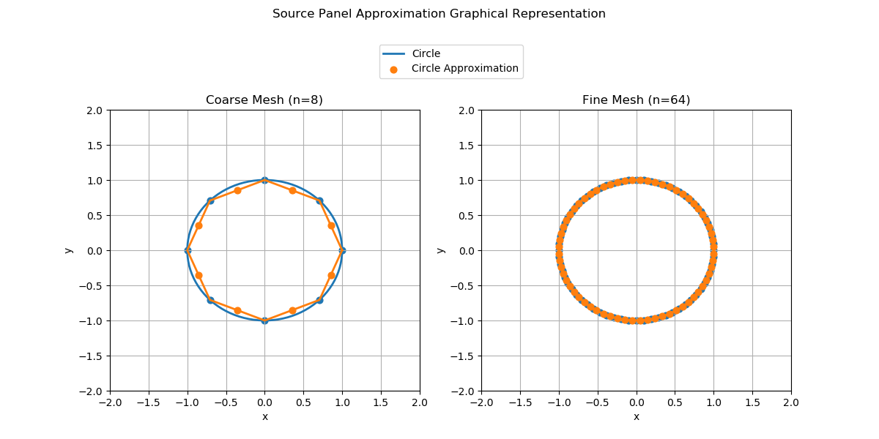

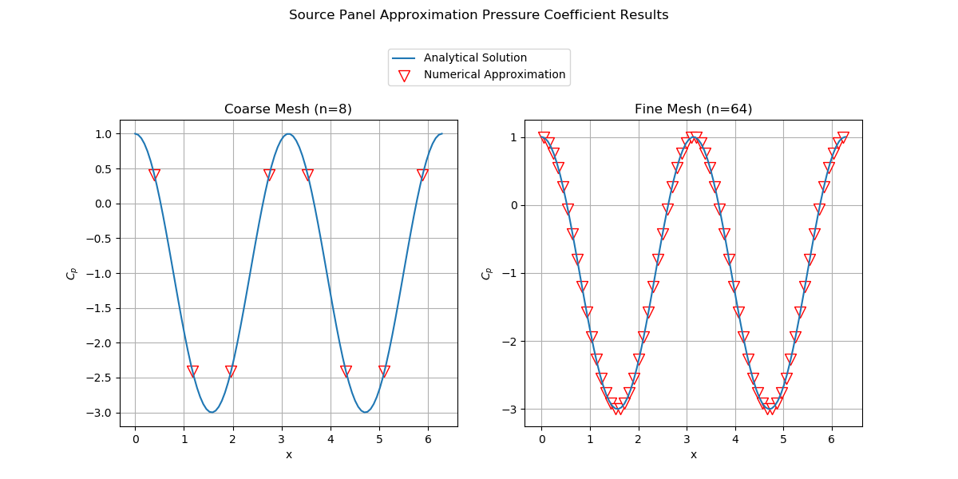

**D. Conclusions**

1. The results got closer to the analytical solution. For the first geometry graph, the panels more closely resembled the shape of the circle. For the Cp graph, the numerical result lead to a more smoothed out cosine curve.
2. The code compared very well to the analytical solution. As mentioned in my answer to question 1, the numerical approximation more closely resembled the analytical solution as the number of panels increased.
3. In the real world, we would expect the results to resemble the general shape of the numerical results however, the peaks and troughs would likely be smaller magnitudes due to real world effects that our assumptions do not take into account such as skin friction.

**E. Code (check to make sure I didn’t make any updates to this before turning in)**

import numpy as np

from matplotlib import pyplot as plt

from scipy import integrate

*#Defining Panel Method*

class Panel:

    def __init__(self, xa, ya, xb, yb):

        self.xa, self.ya=xa,ya

        self.xb, self.yb=xa,yb

        self.xc, self.yc = (xa+xb)/2,(ya+yb)/2

        self.length=np.sqrt((xb-xa)**2+(yb-ya)**2)

        if (xb-xa) <= 0.0:

            self.beta=np.arccos((yb-ya)/self.length)

        elif (xb-xa) > 0.0:

            self.beta=np.pi+np.arccos(-(yb-ya)/self.length)

        self.lambda_ = 0.0

        self.vt = 0.0

        self.cp = 0.0

*#Integral of panel contribution at the center-point in the normal direction*

def normalIntegral(p_i,p_j):

    def integrand(sourcesheet):

        return (((p_i.xc - (p_j.xa-np.sin(p_j.beta)*sourcesheet))*np.cos(p_i.beta) +

                 (p_i.yc - (p_j.ya+np.cos(p_j.beta)*sourcesheet))*np.sin(p_i.beta))/

                ((p_i.xc - (p_j.xa-np.sin(p_j.beta)*sourcesheet))**2 +

                 (p_i.yc - (p_j.ya+np.cos(p_j.beta)*sourcesheet))**2))

    return (integrate.quad(integrand,0.0,p_j.length)[0])

*#Integral of panel contribution at the center-point in the tangential direction*

def tangentialIntegral(p_i,p_j):

    def integrand(sourcesheet):

        return ((-(p_i.xc - (p_j.xa-np.sin(p_j.beta)*sourcesheet))*np.sin(p_i.beta) +

                  (p_i.yc - (p_j.ya+np.cos(p_j.beta)*sourcesheet))*np.cos(p_i.beta))/

                 ((p_i.xc - (p_j.xa-np.sin(p_j.beta)*sourcesheet))**2 +

                  (p_i.yc - (p_j.ya+np.cos(p_j.beta)*sourcesheet))**2))

    return (integrate.quad(integrand,0.0,p_j.length)[0])

*#Freestream*

U_inf = 1

*#Definition of Geometry put in Freestream flow*

*#Cylinder*

*#delta theta*

dtheta=100

*#Radius*

R = 1

*#Center location*

x_0, y_0 = 0.0, 0.0

*#Theta array*

theta_a = np.linspace(0.0,2*np.pi,dtheta)

X_cylinder, Y_cylinder = (x_0 + R*np.cos(theta_a),

                          y_0 + R*np.sin(theta_a))

*#Plot of Cylinder*

x_figsize = 6

y_figsize = 12

figure_1, (ax1, ax2) = plt.subplots(1,2, figsize=(y_figsize,x_figsize))

figure_1.suptitle('Source Panel Approximation Graphical Representation')

plt.subplots_adjust(top=0.75)

ax1.grid()

ax1.set_title('Coarse Mesh (n=8)')

ax1.set(xlabel='x',ylabel='y')

ax1.plot(X_cylinder,Y_cylinder,linewidth=2)

ax1.set_xlim([-2,2])

ax1.set_ylim([-2,2])

ax2.set_title('Fine Mesh (n=64)')

ax2.grid()

ax2.set(xlabel='x',ylabel='y')

ax2.plot(X_cylinder,Y_cylinder,linewidth=2, label='Circle')

ax2.set_xlim([-2,2])

ax2.set_ylim([-2,2])

*### Course ###*

*#Break Geometry into Panels*

number_panels = 8

*#Panel endpoints*

x_ends = R*np.cos(np.linspace(0.0,2*np.pi,number_panels+1))

y_ends = R*np.sin(np.linspace(0.0,2*np.pi,number_panels+1))

*#Create Panels*

panels=np.empty(number_panels,dtype=object)

for i in range(number_panels):

    panels[i]=Panel(x_ends[i],y_ends[i],x_ends[i+1],y_ends[i+1])

*#Plot of panels*

ax1.plot(x_ends,y_ends,linewidth=2)

ax1.scatter([p.xa for p in panels], [p.ya for p in panels],s=40)

ax1.scatter([p.xc for p in panels], [p.yc for p in panels],s=40,zorder=3)

*#Source Influence Matrix*

Matrix_A = np.empty((number_panels, number_panels), dtype=float)

np.fill_diagonal(Matrix_A, 0.5)

for i, p_i in enumerate(panels):

    for j, p_j in enumerate(panels):

        if i != j:

            Matrix_A[i, j] = 0.5/np.pi * normalIntegral(p_i,p_j)

*#RHS of system*

b = -U_inf * np.cos([p.beta for p in panels])

lambda_ = np.linalg.solve(Matrix_A, b)

for i, panel in enumerate(panels):

    panel.lambda_ = lambda_[i]

*#Source Influence Matrix 2*

Matrix_A = np.empty((number_panels, number_panels), dtype=float)

np.fill_diagonal(Matrix_A, 0.0)

for i, p_i in enumerate(panels):

    for j, p_j in enumerate(panels):

        if i != j:

            Matrix_A[i, j] = 0.5/np.pi * tangentialIntegral(p_i,p_j)

*#RHS of system*

b = -U_inf * np.sin([panel.beta for panel in panels])

*#tangent velocity*

V_tangential = np.dot(Matrix_A, lambda_) + b

for i, panel in enumerate(panels):

    panel.vt = V_tangential[i]

*#Numerical Pressure Coefficient*

for panel in panels:

    panel.cp = 1.0 - (panel.vt/U_inf)**2

*#Convert Numerical Approximation Results to Polar Coordinates*

center_tup=zip([p.xc for p in panels],[p.yc for p in panels])

delta_list=[]

for each_center in (list(center_tup)):

    if each_center[1]>0:

        delta=np.arctan2(each_center[1],each_center[0])

    elif each_center[1]<=0:

        delta=(2*np.pi + np.arctan2(each_center[1],each_center[0]))

    delta_list.append(delta)

*#Analytical Pressure Coefficient*

c_p = 1.0 - 4*(Y_cylinder/R)**2

figure_2, (axx1, axx2) = plt.subplots(1,2, figsize=(y_figsize,x_figsize))

plt.subplots_adjust(top=0.75)

figure_2.suptitle('Source Panel Approximation Pressure Coefficient Results')

axx1.grid()

axx1.set_title('Coarse Mesh (n=8)')

axx1.set(xlabel='x',ylabel='$C_p$')

axx1.plot(theta_a, c_p)

axx1.scatter(delta_list, [p.cp for p in panels],color='white',marker='v',edgecolors='r',s=100,zorder=2)

*### Fine ###*

*#Break Geometry into Panels*

number_panels = 64

*#Panel endpoints*

x_ends = R*np.cos(np.linspace(0.0,2*np.pi,number_panels+1))

y_ends = R*np.sin(np.linspace(0.0,2*np.pi,number_panels+1))

*#Create Panels*

panels=np.empty(number_panels,dtype=object)

for i in range(number_panels):

    panels[i]=Panel(x_ends[i],y_ends[i],x_ends[i+1],y_ends[i+1])

*#Plot of panels*

ax2.plot(x_ends,y_ends,linewidth=2)

ax2.scatter([p.xa for p in panels], [p.ya for p in panels],s=40)

ax2.scatter([p.xc for p in panels], [p.yc for p in panels],s=40,zorder=3, label='Circle Approximation')

ax2.legend(loc='upper right', bbox_to_anchor=(0.15,1.25))

*#Source Influence Matrix*

Matrix_A = np.empty((number_panels, number_panels), dtype=float)

np.fill_diagonal(Matrix_A, 0.5)

for i, p_i in enumerate(panels):

    for j, p_j in enumerate(panels):

        if i != j:

            Matrix_A[i, j] = 0.5/np.pi * normalIntegral(p_i,p_j)

*#RHS of system*

b = -U_inf * np.cos([p.beta for p in panels])

lambda_ = np.linalg.solve(Matrix_A, b)

for i, panel in enumerate(panels):

    panel.lambda_ = lambda_[i]

*#Source Influence Matrix 2*

Matrix_A = np.empty((number_panels, number_panels), dtype=float)

np.fill_diagonal(Matrix_A, 0.0)

for i, p_i in enumerate(panels):

    for j, p_j in enumerate(panels):

        if i != j:

            Matrix_A[i, j] = 0.5/np.pi * tangentialIntegral(p_i,p_j)

*#RHS of system*

b = -U_inf * np.sin([panel.beta for panel in panels])

*#tangent velocity*

V_tangential = np.dot(Matrix_A, lambda_) + b

for i, panel in enumerate(panels):

    panel.vt = V_tangential[i]

*#Numerical Pressure Coefficient*

for panel in panels:

    panel.cp = 1.0 - (panel.vt/U_inf)**2

*#Convert Numerical Approximation Results to Polar Coordinates*

center_tup=zip([p.xc for p in panels],[p.yc for p in panels])

delta_list=[]

for each_center in (list(center_tup)):

    if each_center[1]>0:

        delta=np.arctan2(each_center[1],each_center[0])

    elif each_center[1]<=0:

        delta=(2*np.pi + np.arctan2(each_center[1],each_center[0]))

    delta_list.append(delta)

*#Analytical Pressure Coefficient*

c_p = 1.0 - 4*(Y_cylinder/R)**2

axx2.grid()

axx2.set_title('Fine Mesh (n=64)')

axx2.set(xlabel='x',ylabel='$C_p$')

axx2.plot(theta_a, c_p, label='Analytical Solution')

axx2.scatter(delta_list, [p.cp for p in panels],color='white',marker='v',edgecolors='r',s=100,zorder=2, label='Numerical Approximation')

axx2.legend(loc='upper right', bbox_to_anchor=(0.15,1.25))

figure_1.savefig('Source Panel Circle Plot')

figure_2.savefig('Source Panel Cp')